Authorship Form

The undersigned authors hereby affirm that the manuscript entitled:

“Comparative Physicochemical and Ultrastructural Characterization of Extracellular Vesicle-Enriched Preparations from Blood, Urine, and Honey”

is original and all the statements asserted as facts are based on the author(s) investigation and/or research. The manuscript, in whole or in part, has not previously been published, nor is it under consideration of publication elsewhere. Permission for duplicate publication of the herein copyrighted materials must be officially granted by the Iranian Biomedical Journal. By signing this form, the authors acknowledge that they have participated in the work in a substantive way. And the corresponding author takes full responsibility for the data presented herein.

All authors must sign: (Please mark the corresponding author)

Date | Name | Signatures | ORCID ID
1. 06/08/2026 | Glenn Marchelinno Souissa | 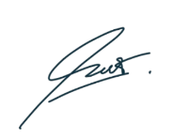 | 0009-0006-1783-1208
2. 06/08/2026 | Bryan Christopher Wiraputra | 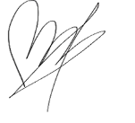 | 0009-0003-8860-3833
3. 06/08/2026 | Deby Deby | 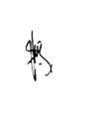 | 0009-0006-2394-1972
4. 06/08/2026 | Purnamawati |  | 0000-0002-4804-3785
5. 06/08/2026 | Eden Steven | 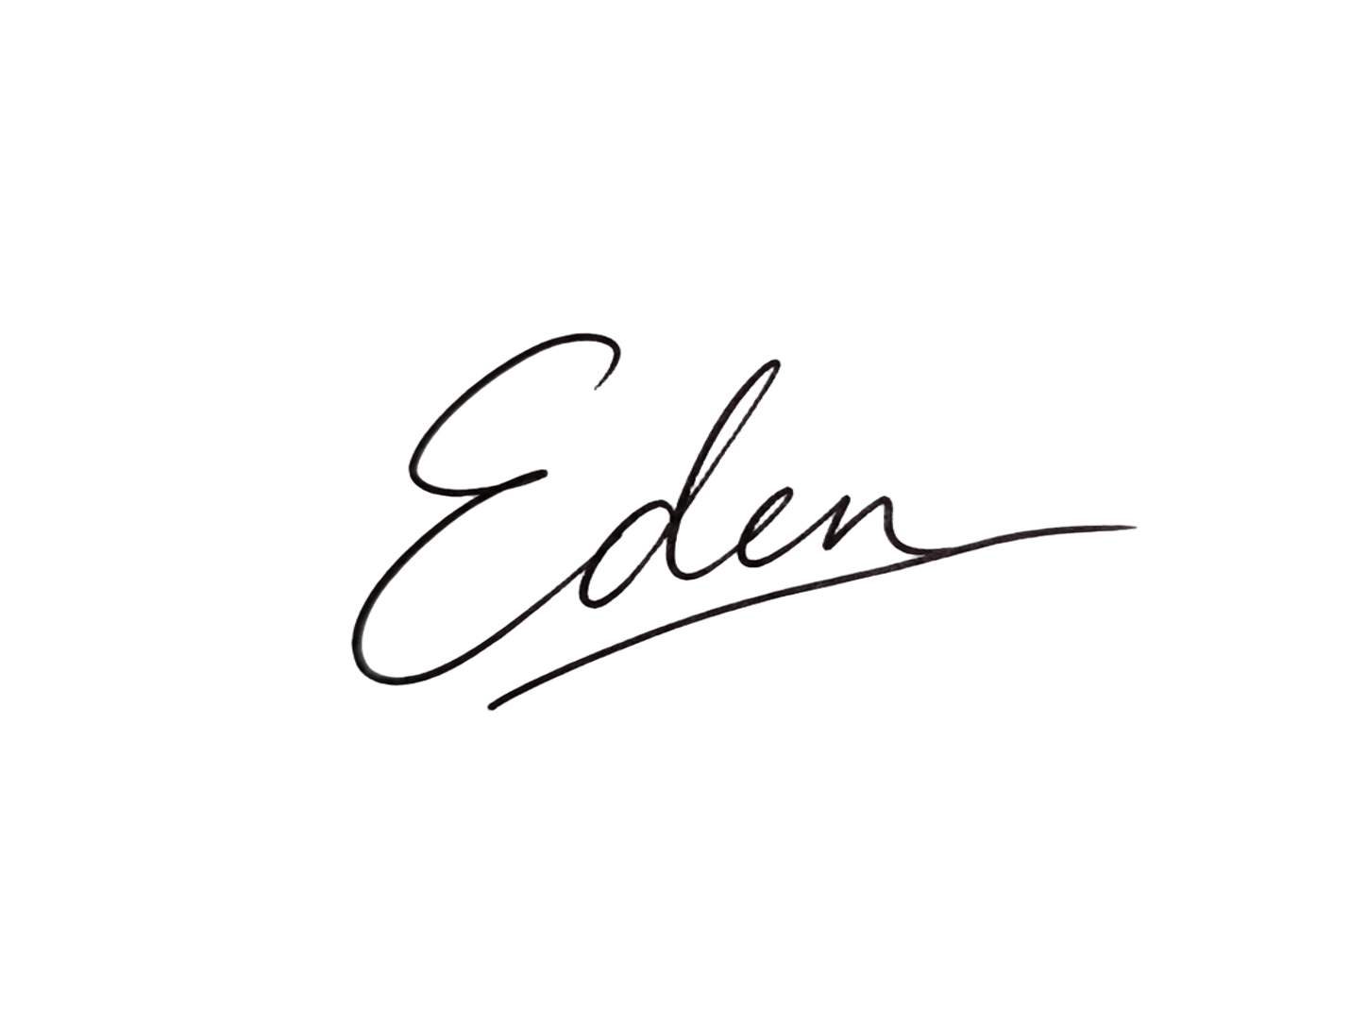 | 0000-0003-4591-487X
6. 06/08/2026 | Yudhi Nugraha | 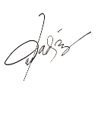 | 0000-0003-1186-4093
7. 06/08/2026 | Ahmad Novi Muslimin | 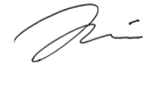 | 0000-0002-2174-5461
8. 06/08/2026 | Agus Limanto |  | 0000-0002-6037-1271

